IBM SELF-SCREENING QUESTIONNAIRE

1. Have you traveled to mainland China, Hong Kong or Taiwan in the last 14 days OR have been in close contact with a person confirmed to have a novel coronavirus infection? If yes/No - NO
   1. Do self-quarantine for 14 days.
   2. Seek medical care right away if you experience any symptoms. Before you go to a doctor’s office or emergency room, call ahead and tell them about your recent travel and your symptoms. c. Avoid contact with others.
   3. Do not travel while sick.
   4. Cover your mouth and nose with a tissue or your sleeve (not your hands) when coughing or sneezing.
   5. Wash hands often with soap and water for at least 20 seconds to avoid spreading the virus to others. Use an alcohol-based hand sanitizer that contains at least 60% alcohol, if soap and water are not available.
2. Do you have any of the following symptoms?
   1. cough : - NO
   2. fever :- NO
   3. shortness of breath :- NO
   4. difficulty of breathing or other respiratory symptoms :- NO

If you answer yes to any of these, you should seek medical care right away. Before you go to a doctor’s office or emergency room, call ahead and tell them your symptoms.

Reminder:

If at any point during the meeting and within 14 days after the meeting you experience any flu-like symptoms like fever, cough, shortness of breath, difficulty of breathing or tiredness, you should seek immediate medical attention.

Date: 19/06/2024

Name: Jaya Krishna Seethagari

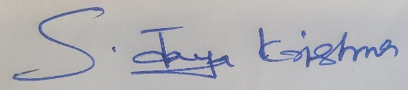

Sign: